**CASE STUDY**

**MODULE 5**

**VPC**

**PRODUCTION NETWORK**

**DONE BY**

**RANJITH KUMAR**

**Problem Statement:**

You work for XYZ Corporation and based on the expansion requirements of your

corporation you have been asked to create and set up a distinct Amazon VPC for

the production and development team. You are expected to perform the following

tasks for the respective VPCs.

**Production Network:**

1. Design and build a 4-tier architecture.

2. Create 5 subnets out of which 4 should be private named app1, app2,

dbcache and db and one should be public, named web.

3. Launch instances in all subnets and name them as per the subnet that

they have been launched in.

4. Allow dbcache instance and app1 subnet to send internet requests.

5. Manage security groups and NACLs.

STEP 1 : Open VPC from aws services

STEP 2 : Go to VPC > Subnet > Create Subnet

STEP 3 : Create route table for the public and private subnet

STEP 4 : Associate subnets to the route table(Public ,Private & Partial)

STEP 5 : Create a internet gateway to aloow communication between vpc and internet

STEP 6 : Create NAT gateway in public subnet to access internet in the private subnet

STEP 7 : Routed the internet gateway and NAT gateway in the routetable

STEP 8 : Create 3 instances running in the production VPC and subnet .

STEP 9 : Security group have been managed to route the traffic coming inside our instance

STEP 10 : NACL have been mananged to allow/deny traffic at our subnet

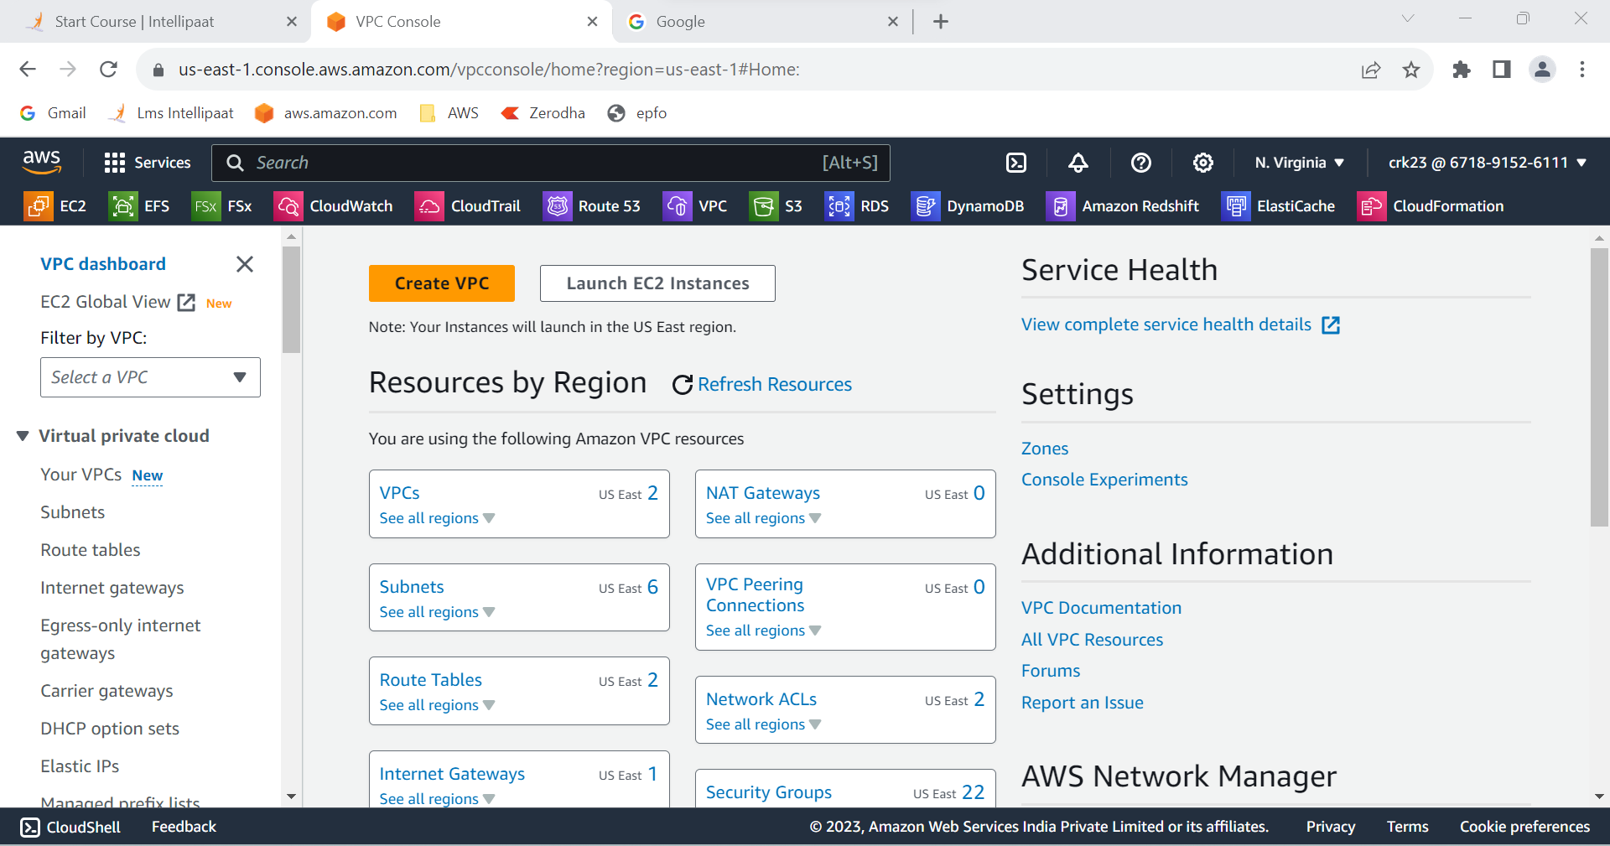

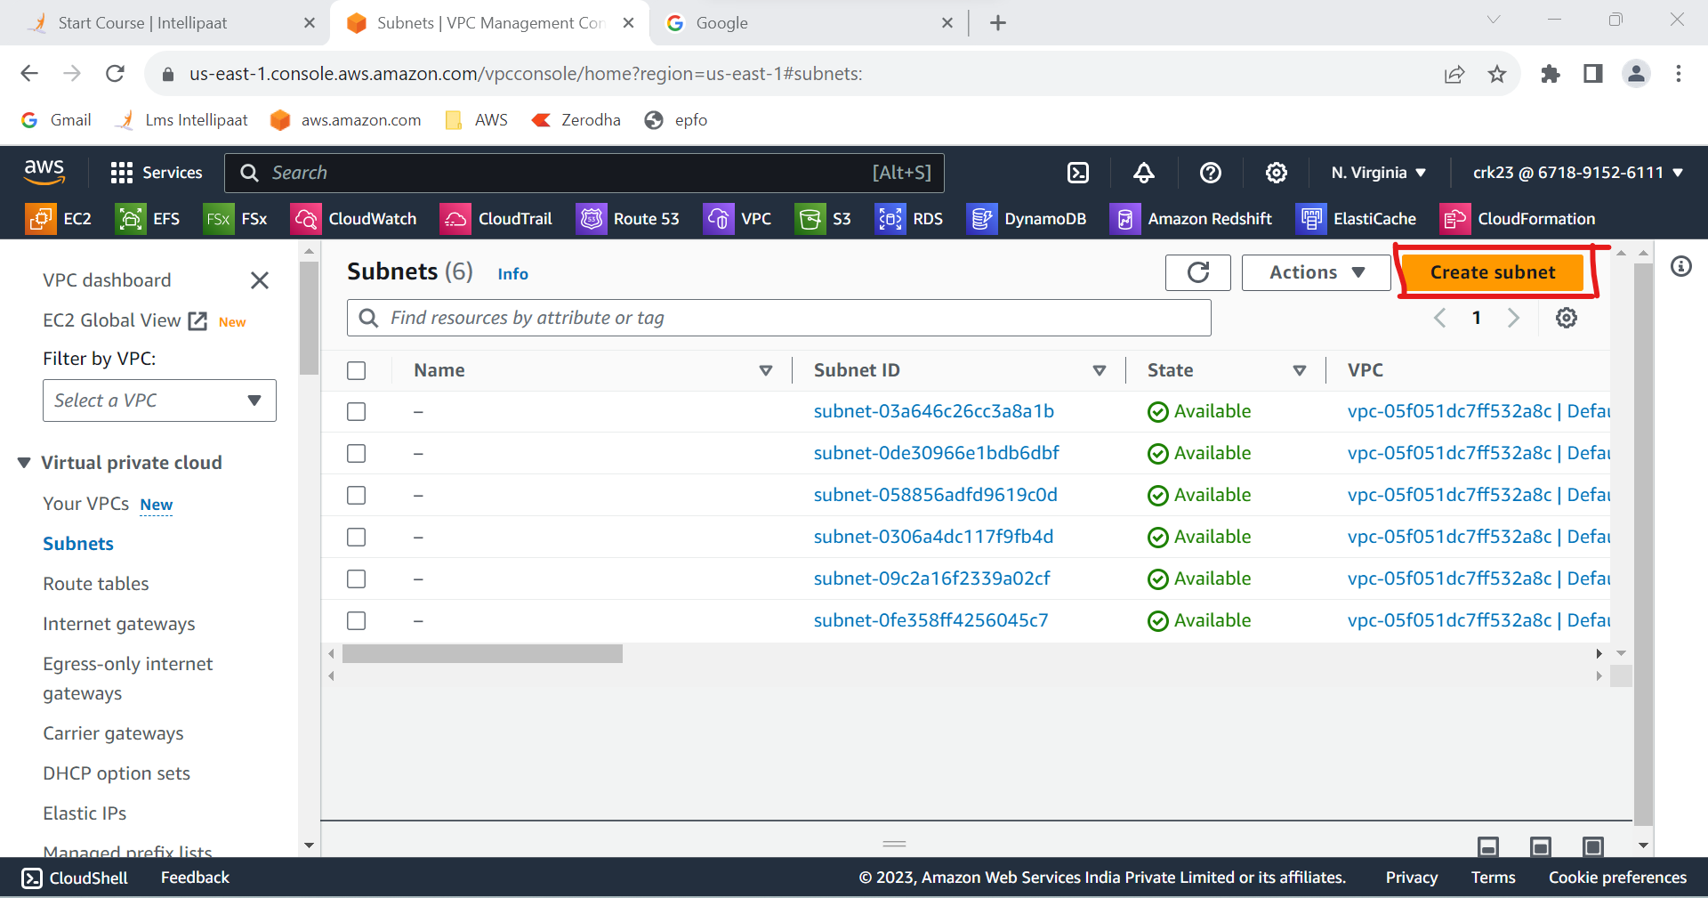

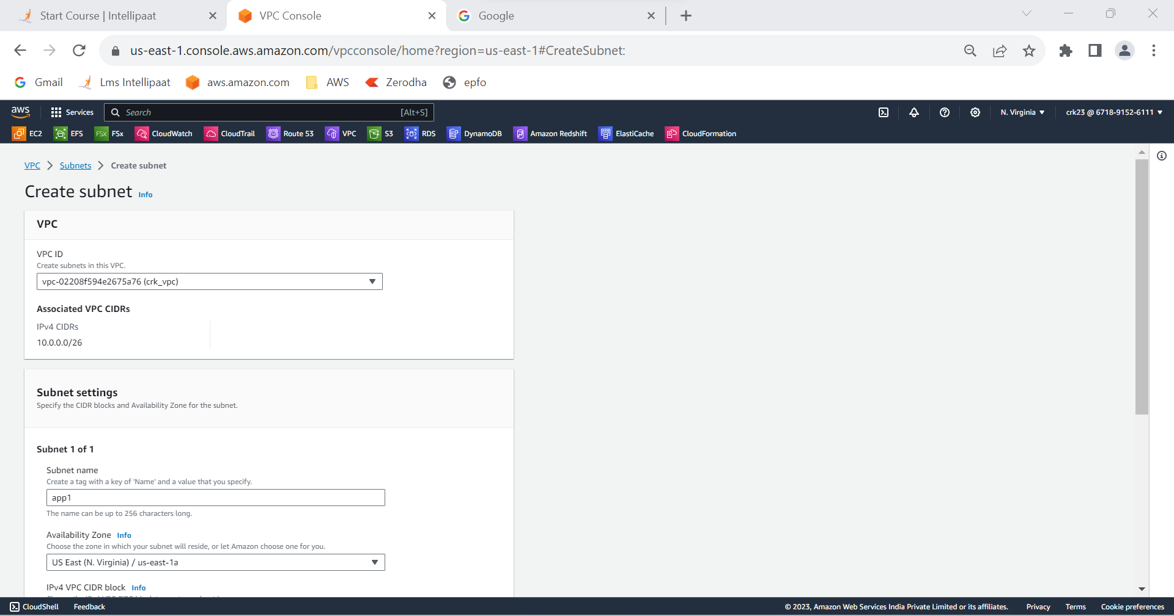

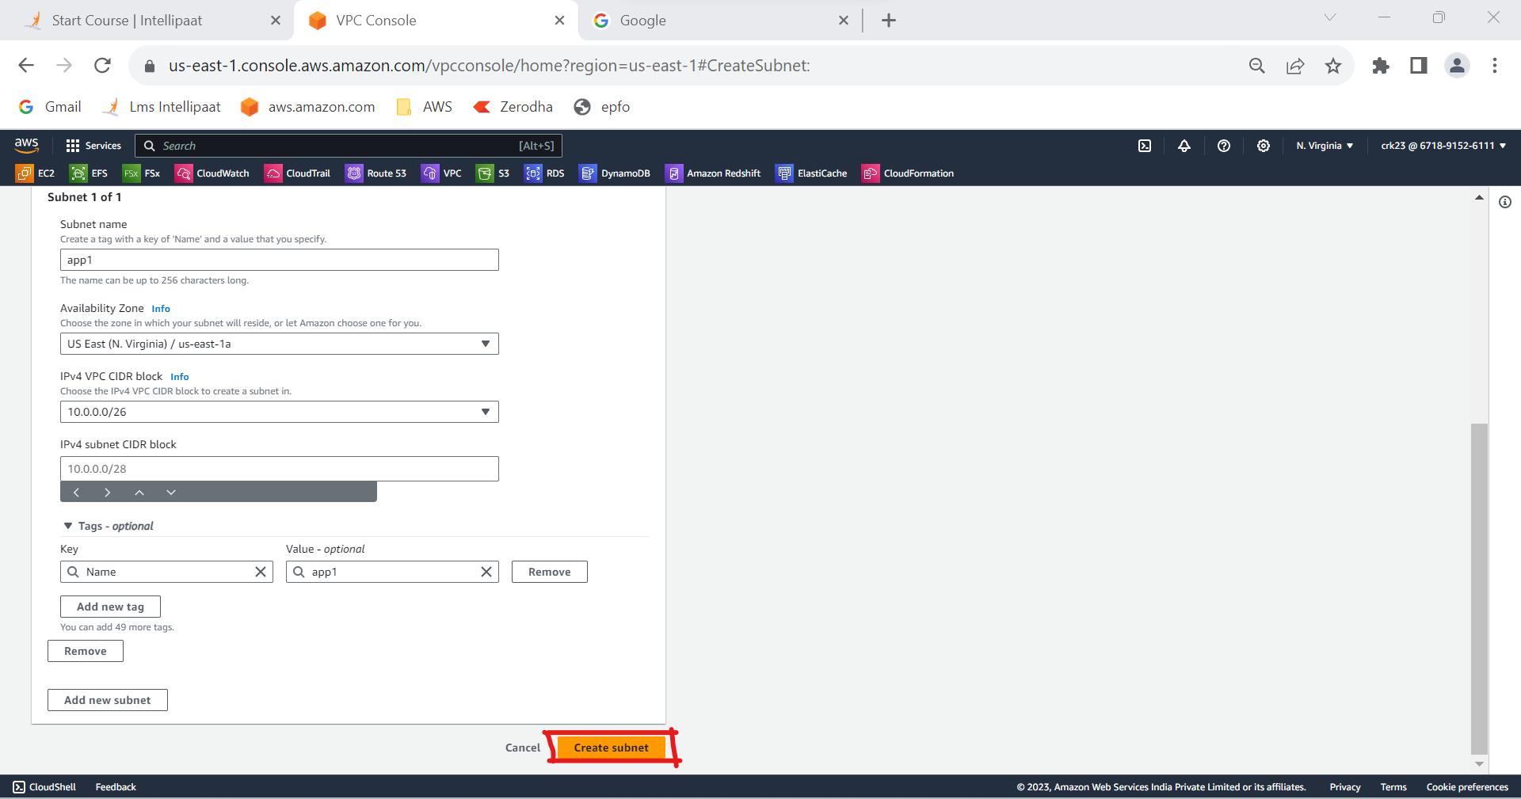

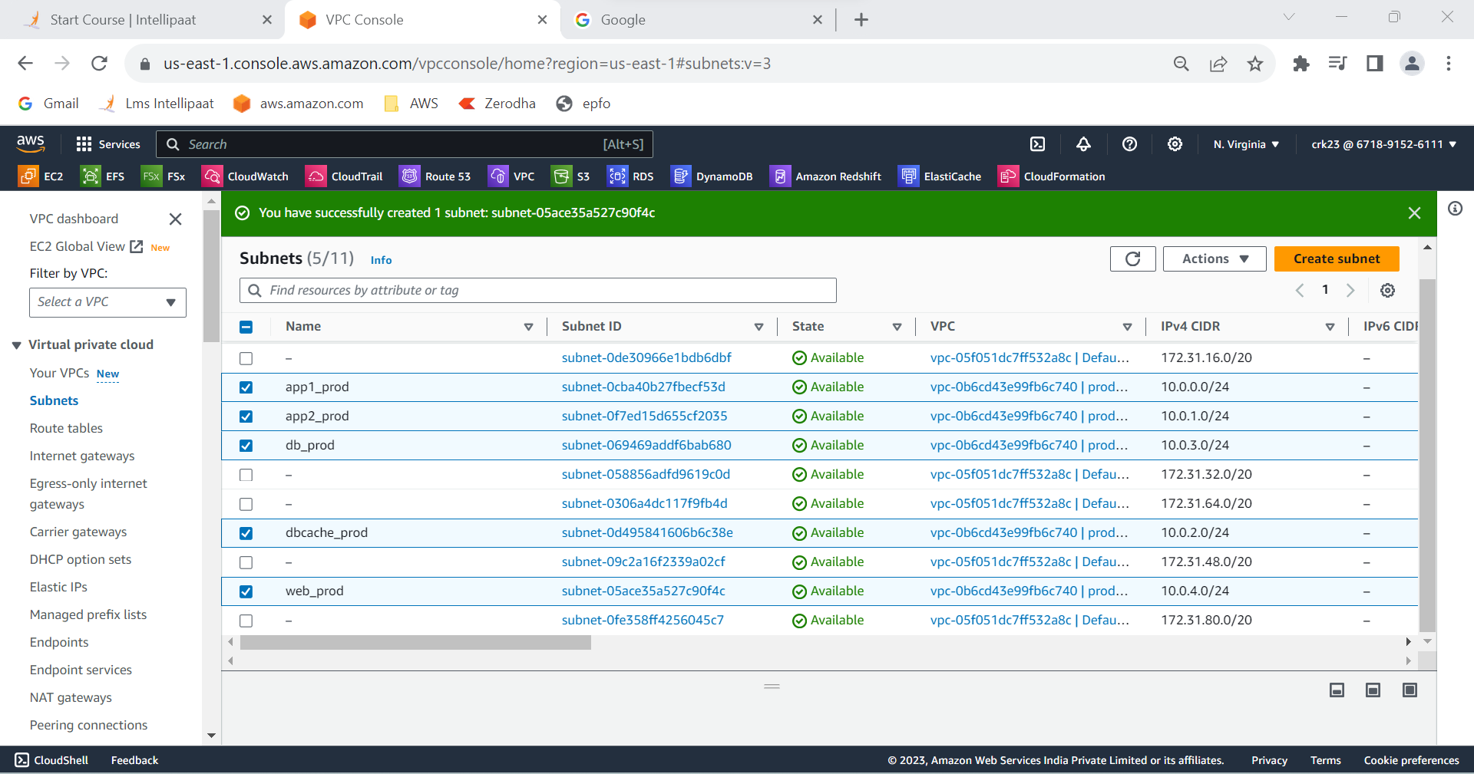

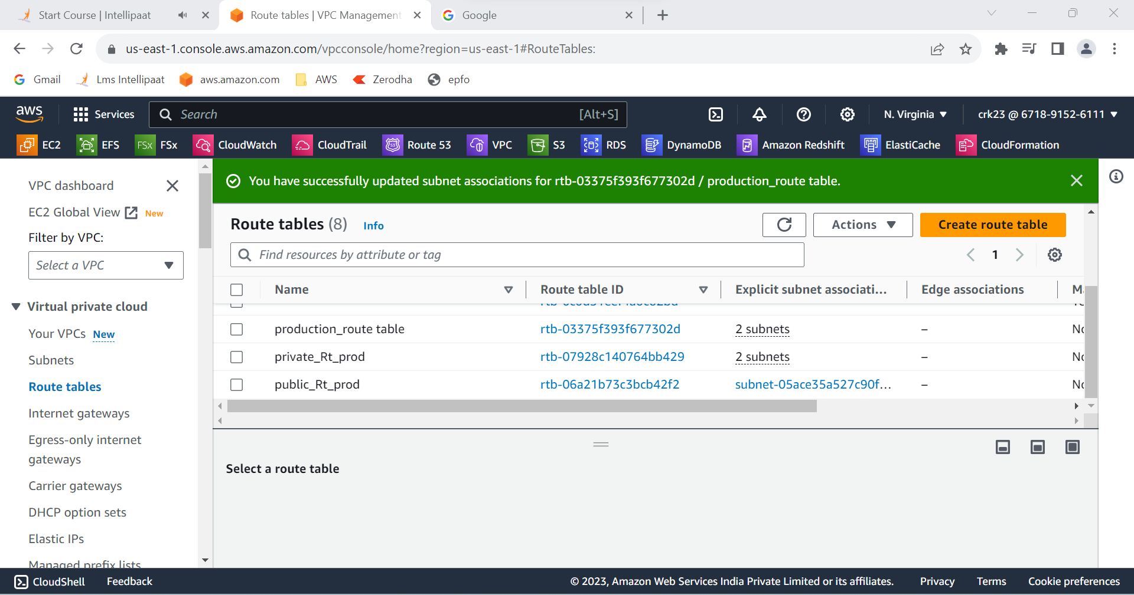

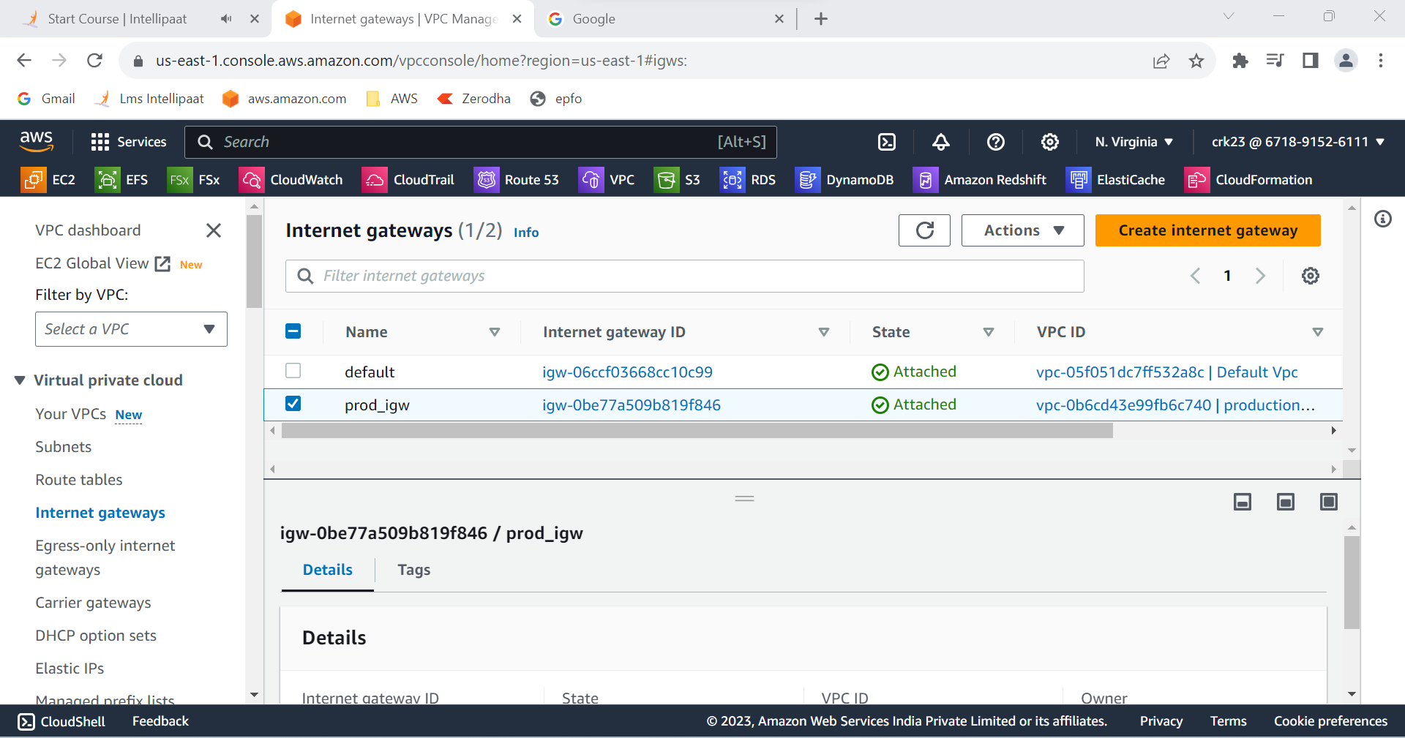

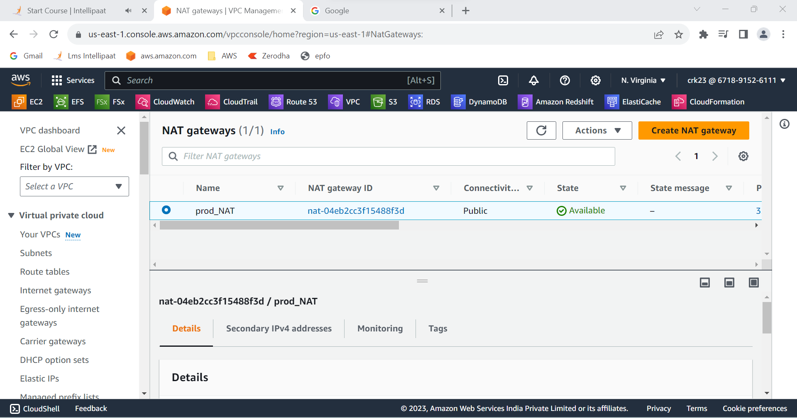

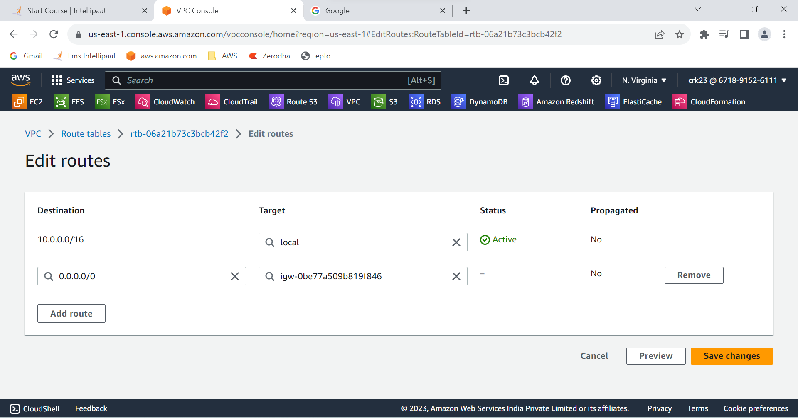

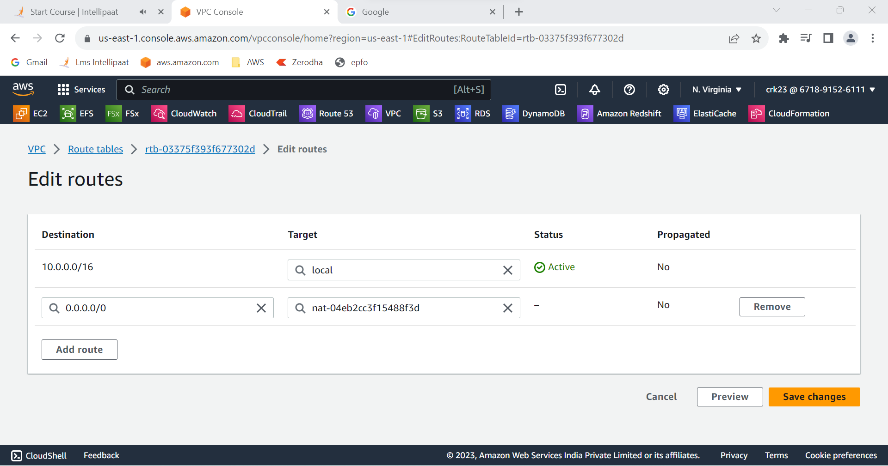

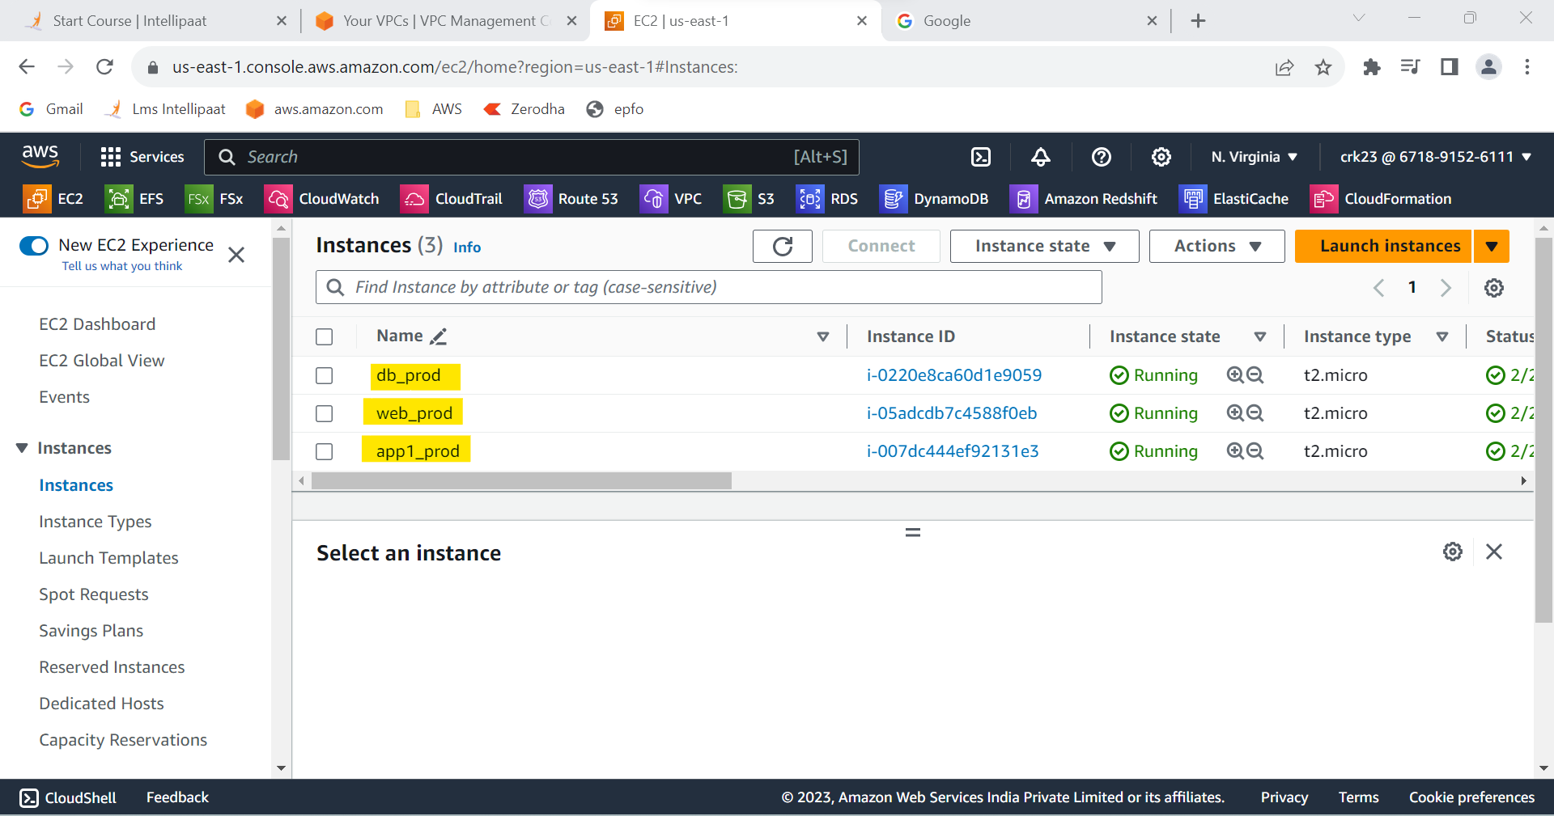

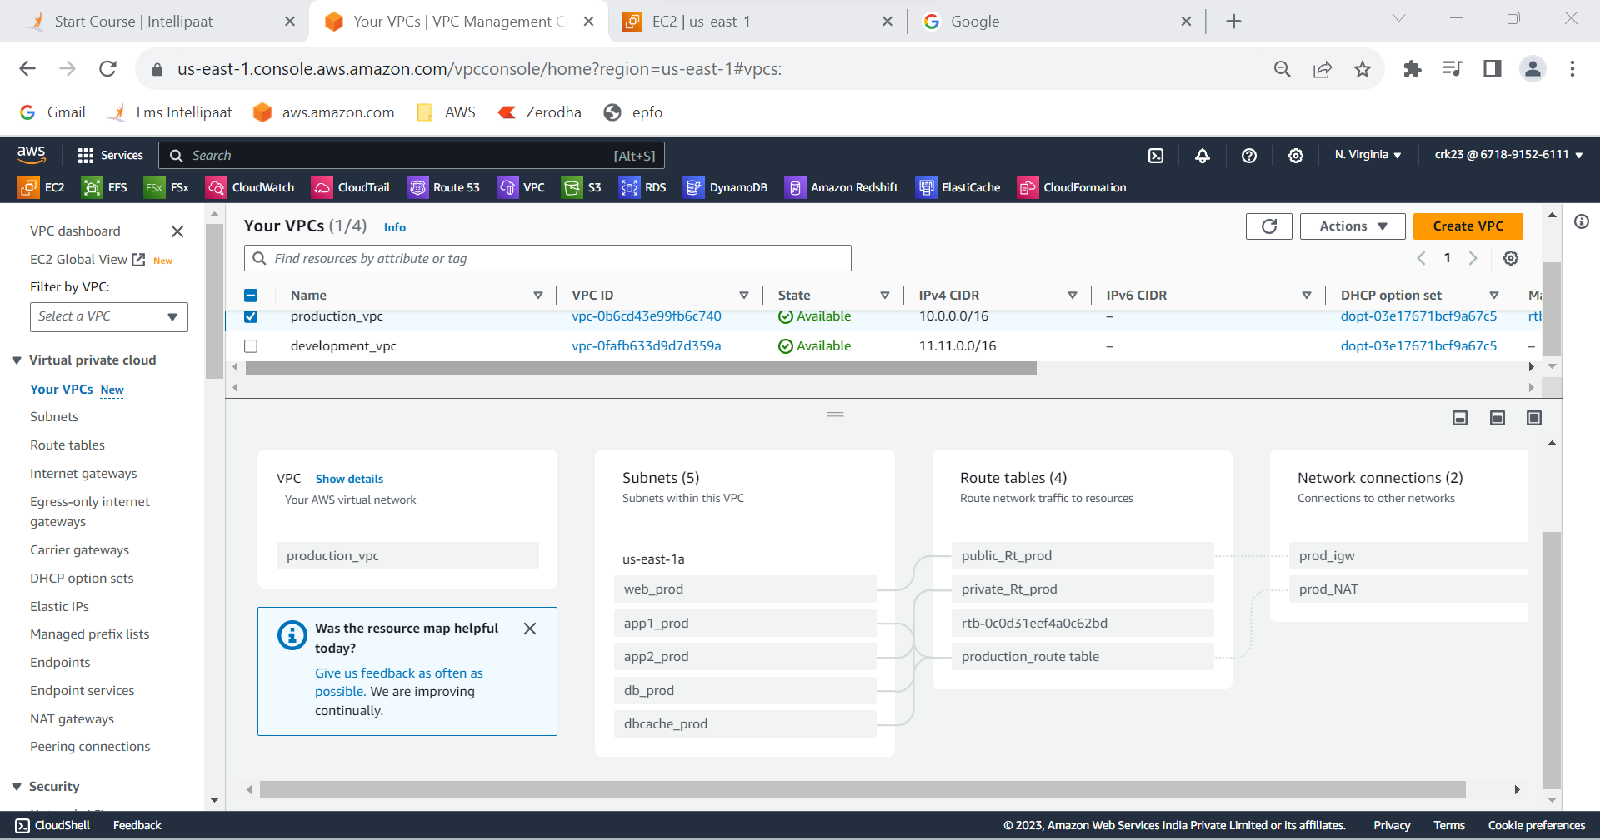

**OUTPUT :**

Created 5 subnets out of which 4 is private named app1, app2,

dbcache and db and one ispublic, named web and launched instances in all subnets and name them as per the subnet and Allowed dbcache instance and app1 subnet to send internet requests.Managed security groups and NACLs.